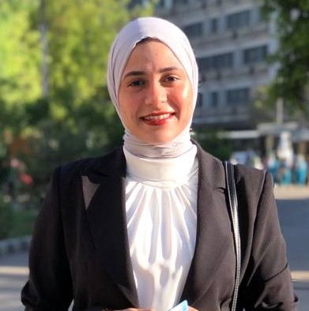 | Aliaa Youssef M. A. ElQadi  E-mail: aliaaelqadi@aun.edu.eg  Mobile number: 00201111438034

Education and Qualifications

B.Sc. In Microbiology, Faculty of science, Assiut University. | 2018 - 2022

Academic Positions

Demonstrator at Applied Biotechnology Department, Molecular Biology Researches & Studies Institute, Assiut University, Asyut, Egypt | 2023 – now

Workshops

General English Course | 25th May ~ 30th Aug.2016
Medical Analysis at Hi Lab for Chemical Analysis | 1st ~ 30th Jun.2019
Chemical Analysis of Drinking Water and Sewage | 1ST ~ 15 Aug.2021
DNA Analysis Techniques and Plant Tissue Culture | 1st ~ 30th Sep.2021
(MOS) Microsoft Office Specialist | 30th Jul. ~ 5th Sep.2022
Some Basics of molecular Biology Techniques | 19th ~ 21st Jun. 2023
ISO/IEC 17025:2017 | 14th Sep. 2023
Document Control | 1st ~ 2nd Oct. 2023
Internal Audit | 3rd ~ 4th Nov. 2023
Protein Analysis Techniques | 21st ~ 22nd Nov. 2023
Health and Safety | 19th ~ 20th Dec. 2023

Conferences

1st Conference of Applied Molecular Biology | 8th ~ 9th May. 2023
1st Science Forum Environmentally Friendly Projects | 15th May. 2023

Researcher Information

https://www.aun.edu.eg/molecular_biology_institute/index.php/ar/aliaa-youssef-elqadi | Official website
https://www.researchgate.net/profile/Aliaa-Youssef-Elqadi | ResearchGate website
https://scholar.google.com/citations?hl=en&user=vm_Cqo8AAAAJ | Google Scholar website

